Block Beneficiary Payouts
Author/s: Rishav Singh
Team/Pod: Payouts Core| BU: RazorpayX
Published Date: Jun 13, 2024

Reviewer Name | Reviewed Date | Status
 |  | Approved
 |  | Approved

1. Problem Statement
For Certain Beneficiary Banks, there is a use case of Blocking the Payouts to specific or all modes. This feature blocks the payouts made to those beneficiaries IFSCs.
If these Payouts are not blocked, it results in pending payouts cases like Deemed Success or a wide range of unknown error codes, resulting in high SLA of the payouts and Unresolved Pending Payouts.

2. Introduction & Scope
The goal of this feature is to enhance the payout process by implementing a blocking mechanism for specific beneficiary IFSCs and modes. This will help in reducing pending payout cases and improve the SLA for payouts.

In-Scope:
- Block a specific IFSC - Mode pair for all transfers.
- Block a Merchant with a specific IFSC - Mode pair.
- Beneficiary Blacklisting : Block a specific Beneficiary Fund Account ID / Account Number.
- Config-driven process allowing required configurations to be added or edited through the Config Server.

3. Out of Scope
Blocking Transfers on any other criteria other than Beneficiary Account details, like Blocking based on Merchant Id and Preferred Channel.

4. Futuristic Scope
- Dynamic Blocking Rules: Implementing dynamic and customizable blocking rules that can adapt based on real-time analytics or merchant self-serve
- Expanded Criteria: Extending the blocking mechanism to include additional criteria, such as transaction amount, time of day and other factors.

5. Assumptions, Goals & Non-Goals
Payout Entities will be created on API as well as Transfer entities will be created at FTS end, once the Transfer goes to Transfer Processor we will do a check on the requirement for blocking Beneficiary, after which the Transfer is failed and then according to the Payout is updated on API.

Goals

- Ensure that the system can effectively block payouts based on beneficiary account details, IFSC codes, and preferred modes.
- Minimize the occurrence of unresolved pending payouts and reduce the SLA times for payouts.
- Provide a configurable and flexible system that allows easy addition or modification of blocking rules.

6. Current Architecture / Current HLD
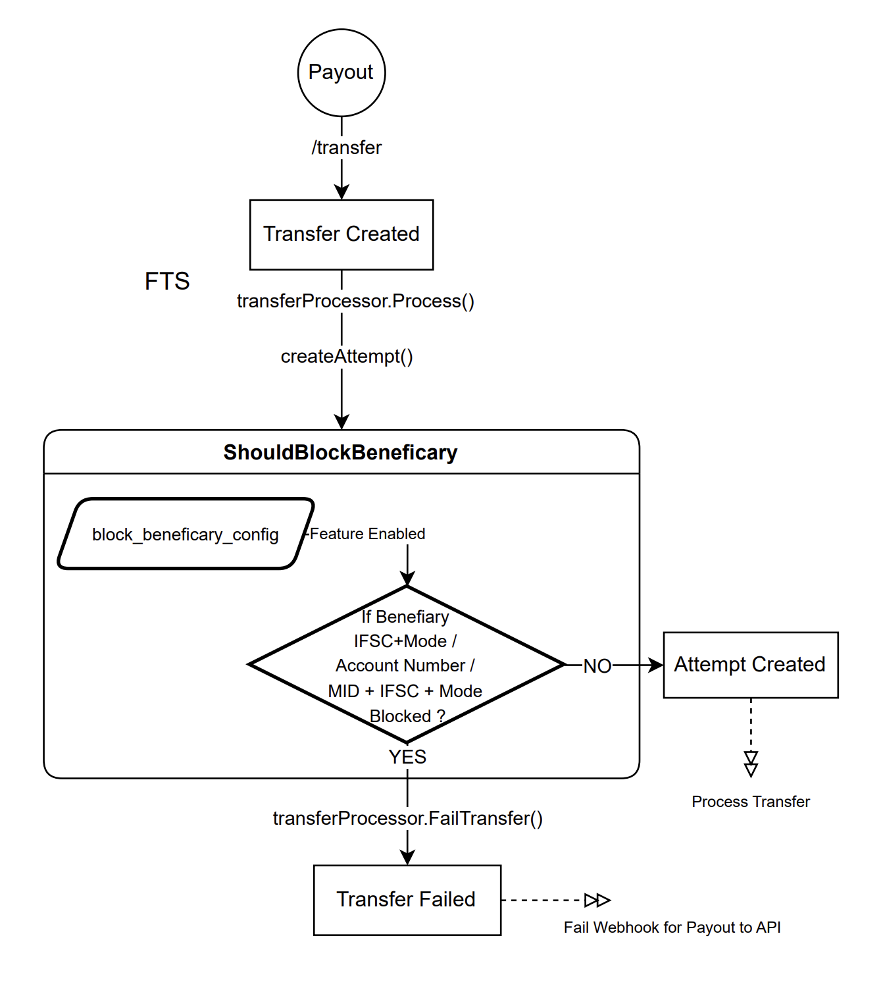

7. Final Approach - Specifications
Sample Config Structure to Block Beneficiaries :
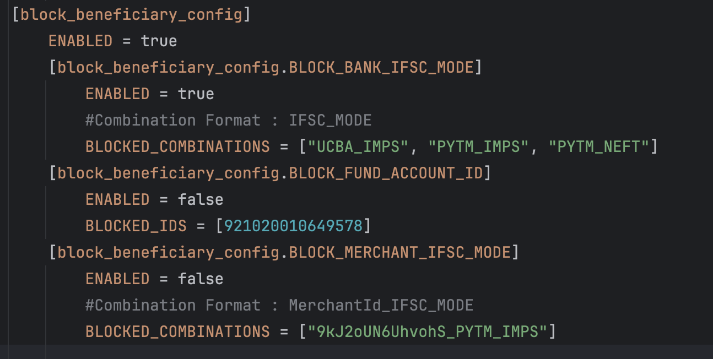
This can be edited anytime through the Config server on Admin Dashboard

8. Test Cases
All the Possible Positive and Negative Cases have been accounted for and added in the Test Cases Sheet

9. Roll Back
The code can immediately roll back by disabling the experiment with feature name : “block_ifsc_experiment”
Or by disabling the config from config server

